PRODUCT TECHNICAL SPECIFICATIONS

DRIP FITTINGS (ROUND/FLAT)
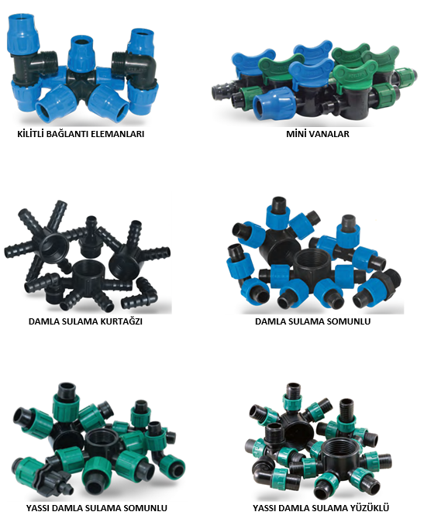

1

1. EXTENT

They are the parts used for mechanical fittings of Polyethylene drip pipes used in agricultural irrigation systems.

2.IMPLEMENTATION

- Agricultural Irrigation
- Landscaping Systems
- Greenhouses

3. MATERIAL PROPERTIES

•Guaranteed Pressure Values;

LOCKED THREADED FITTINGS:PN6

MINI VALVES (DN8): PN4

MINI VALVES (DN8): PN2
- It has been produced from high quality polypropylene raw material and it has resistance to impact.
- Threaded sizes comply with ISO 7-1 Standard.
- Since it does not pass UV rays, it does not allow algae and bacterial growth.
- Inner surfaces are homogeneous and non-porous.
- Water passage diameter of DN 8 Mini valves is 8 mm.
- Water passage diameter of DN 15 Mini valves is 15 mm.
- Conforms to TS EN ISO 9261: “Agricultural irrigation equipment” Standard.

- Lock type fittings are suitable for 16,20,25 and 32 mm low density polyethylene drip blind pipes.
- Barbed fitting and Dripline Nut fitting products are suitable for 16- and 20-mm round drip irrigation pipes.
- Flat dripline irrigation fittings are suitable for single and multi-season 17,22- and 25-mm flat dripline pipes.
- Ringed Flat fittings are suitable for single season 17 mm seamless flat dripline pipes.

2

4. APPEARANCE
When viewed without a magnifying glass, the interior and exterior surfaces of the fittings should be smooth and clean, with no flaking, pitting or other surface defects that would prevent their conformity with this International Standard.

5. PACKAGING
The drip fittings are supplied to the market in the amount specified in the parcel / bag, in a way that they will not be damaged during transportation.

6. MARKING

On the packaging of the mechanical fittings offered to the market.

• Name of the product/Size
• The quantity of the product,
• Company name, address, and other information (brand etc.),
• Raw Material Information (PP)

7. INSPECTION AND EXPERIMENTS

DRIPLINE PIPE TYPE | TEST TEMPERATURE | TEST TIME | TEST PRESSURE
For nonreusable Pipes. | 23 °C | 1 HOUR | PN X 1,2
(Single Season Flat Pipes) | 40 °C | 1 HOUR | PN
For reusable Pipes. | 23 °C | 1 HOUR | PN X 1,8
(Multi-season Pipes) | 40 °C | 1 HOUR | PN
DRIPLINE PIPE TYPE | TEST TEMPERATURE | TEST TIME | PULL FORCE
For Reusable Pipes (Multi-season Pipes) | 23 °C | 15 MİN | 180 N

3

8.SIZES

- LOCK TYPE FITTINGS: 16-20-25-32 mm,
- MINI VALVES (DN8): ½”-3/4”-16-22 mm, (PN4)
- MINI VALVES (DN8): ½”-1 1/4”-16-25 mm, (PN2)
- DRIPLINE BARBED: 16 – 20 – 25 – 32 – 40 – 50 -63 mm,
- DRIP IRRIGATION NUT: 16 – 20 mm,
- FLAT DRIP IRRIGATION NUT: 17 – 22 – 25 mm,
- FLAT DRIP IRRIGATION WITH RING: 17 mm

9. USAGE INFORMATION

- For a proper offtake with the Grommet Gasket, the pipe should be punched 16 mm or 20 mm according to the grommet gasket to be used.
- The pipe should be drilled with a hole diameter of 20 mm, depending on the type of Barbed Fitting to be used for outlet with Barbed Grommet Gasket.
- After the Barbed Fittings are attached to the pipe, the pipe must be tightened with the Poelsan Pipe Clamp.
- Gasketless Outlet is used to get an outlet from Lay flat and Low-Density Polyethylene (LDPE) Pipes (Straight Drip Irrigation Pipe) to Ø16 mm and Ø20 mm Drip Irrigation Pipes.
- To get output with Proper offtake, the pipe must be drilled with a hole diameter of 8 mm.

4

