PRODUCT TECHNICAL SPECIFICATIONS

LAYFLAT FITTINGS & OFFTAKE NIPPLES

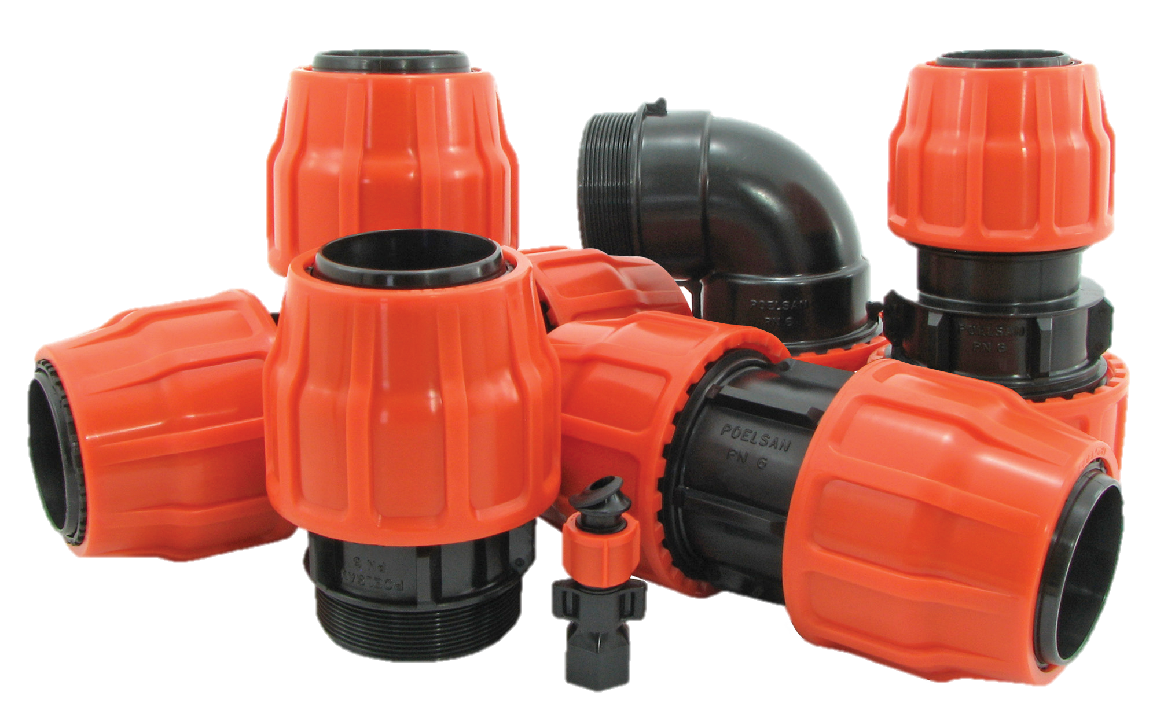

1. EXTENT

They are the parts used for mechanical fittings of PVC and Polyethylene Layflat hoses.

2.IMPLEMENTATION

- Agricultural Irrigation Systems
- Mining
- Construction

1

3. MATERIAL PROPERTIES
- Guaranteed Pressure Value;

- 2” – 2 ½” : PN 10 / 20 0C

- 3” – 4” – 5” : PN 6 / 20 0C

- 6” : PN 4 / 20 0C
- Threaded parts of Layflat fittings comply with ISO-7 norms.
- Since Layflat fittings do not pass ultraviolet rays (UV), they do not allow algae and bacterial growth.
- In the production of Layflat fittings, Materials such as sawdust and scrap are not used. Only original raw materials are used in production.
- Semi-finished products of Layflat Fittings; O-ring placed in the body, inner holder and flat gasket on it, outer holder, and nut on the body.
- Layflat Fittings; threaded parts are suitable for use with ball valves, galvanized fittings, etc.
- Layflat Fittings; It is suitable for the pipe inner diameters in the table.

Product Size | Layflat Pipe Inner Diameter
2" | 52 mm
2 ½" | 65 mm
3" | 77 mm
4" | 103 mm
5" | 128 mm
6" | 153 mm

4. APPEARANCE
When viewed without a magnifying glass, the interior and exterior surfaces of the fittings should be smooth and clean, with no flaking, pitting or other surface defects that would prevent their conformity with this International Standard.

5. PACKAGING
Layflat Fittings products are supplied to the market in packages in the amount specified in the parcel / bag, in a way that they will not be damaged during transportation.

2
6. MARKING

On the products and packages of Layflat fittings offered to the market;
• Pipe Size (inch size) on Nuts
• Rated Pressure (PN)
• POELSAN

7. INSPECTION AND EXPERIMENTS

Layflat fittings are subjected to the leak test at the following pressure values.
SIZE | PRESSURE VALUE | TEST DURATION | TEST TEMPERATURE | TEST PRESSURE
SIZE | (Bar) | (h) | (°C) | (bar)
2"- 2 ½" | 10 | 1 | 20 | 15
3"- 4"- 5" | 6 | 1 | 20 | 9
6" | 4 | 1 | 20 | 6

USAGE INFORMATION

- To get offake with Layflat offtake Nipple, the pipe should be drilled according to the hole diameter to be 13 mm.
- During the assembling of Layflat Fittings, it should be avoided to Layflat Pipe folding point to come up to the opened channels on the outer pipe holder.

3

