PRODUCT TECHNICAL SPECIFICATIONS

VALVE BOXES

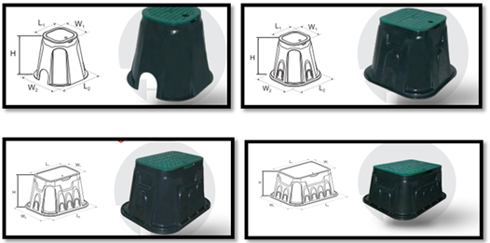

1. EXTENT

They are plastic protection boxes manufactured to protect the valves used in outdoor environments for different purposes from climatic conditions, impacts and external factors such as soil, water, mud.

2.IMPLEMENTATION

- Landscaping Systems
- Agricultural Irrigation
- Construction

1

3. MATERIAL PROPERTIES
- It has been produced from high quality polypropylene raw material.
- It enables easy access to the system equipment which is laid underground.
- Specially designed plastic lock system is available in the lid.
- There are specially cut holes according to pipe diameters for the passages of pipe.

4. APPEARANCE
When plastic valve boxes are examined with the naked eye, they should be homogeneous, free of foreign matter, and surface defects such as bubbles, cracks, deformities, regional color differences should not be seen on the box.

5. PACKAGING
Plastic valve boxes are supplied to the market in nylon-coated packages in a way that they will not be damaged during transportation.

6. MARKING

On the packages of Plastic Ball Valves offered to the market;
- Name of the product/Size
- The quantity of the product,
- Company name, address, and other information (brand etc.),
- Production date,
- At least one of the batch, serial, or code numbers,
- There should be warning information.

2

7. INSPECTION AND EXPERIMENTS

NAME OF THE TEST | UNIT | TESTING METHOD | VALUE
Stiffness | Shore D | TS ISO 48 | 80±5
Intensity | gr/cm³ | EN ISO 1183 | 0,950±0,02
Tensile Strength | MPa | ISO 527-2 | min.20
Elongation | % | ISO 527-2 | min.5
Lid watertightness | - | TS 13716 | There will be no leakage
Masses of valve boxes | % | TS 13716 | %10 tolerance

8.SIZES

Product Size | H x L₁ x L₂ x W₁ x W₂
6” | 235x163x260x163x260 mm
10” | 275x240x375x240x375 mm
12” | 310x385x553x255x420 mm
14” | 310x505x673x355x520 mm

9. USAGE INFORMATION

- Protect against sharp-edged impacts.
- Special cut holes according to pipe diameters should be cut by means of a saw according to need.
- 8 mm Allen key must be used to unlock the locking system.

3

