PRODUCT TECHNICAL SPECIFICATIONS

GREEN SERIES BALL VALVES

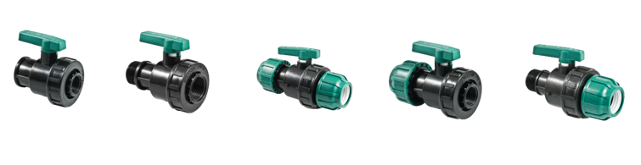

1. EXTENT

Small manually operated Plastic Ball Valves used in Agricultural Irrigation Equipment.

2.IMPLEMENTATION

- Landscaping Systems
- Agricultural Irrigation

1

3. MATERIAL PROPERTIES
- Guaranteed Pressure Value;

¾" – 1" – 1 ¼" – 1 ½" – 2" Ball Valves: PN 10

32 – 40 – 50 – 60 Ball Valves: PN 10
- It has been produced from high quality polypropylene raw material and it has resistance to impact.
- It is possible to provide bidirectional flow in the valve.
- They do not cause any pressure or flow loss during fluid pass.
- They supply simple installation in your system.
- O-rings are made of rubber and provide leak proofness under high pressure.
- It does not contain any harmful compounds which can change the taste or the smell of the water.
- Ball valves comply with ISO 9911 standard.

4. APPEARANCE
When Plastic Ball Valves are examined with the naked eye, they should be homogeneous, free of foreign matter, and surface defects such as bubbles, cracks, deformities, regional color differences should not be seen on the body.

5. PACKAGING
Green Series Ball Valves products are supplied to the market in packages in the amount specified in the parcel / bag, in a way that they will not be damaged during transportation.

6. MARKING

On the packages of Plastic Ball Valves offered to the market;

• Name of the product/Size
• The quantity of the product,
• Company name, address, and other information (brand etc.),
• Production date,
• Rated Pressure (PN)
• Flow Direction

2

7. INSPECTION AND EXPERIMENTS

Name of The Test | ISO | STANDARD SERIAL NUMBER | TEMPERATURE | PN | TEST DURATION (h)
Rotation Moment Required for Closing | ISO 8233 | 7.2.1 | 23°C | PN
Enhanced Rotation Moment Endurance | ISO 8233 | 7.2.2 | 23°C | PN | 1 Dk.
Pressure Loss | ISO 9644 | 7.3 | 23°C | PN
Hydrostatic Internal Pressure Resistance of Valve and Valve Material | ISO 1167 | 7.4 | 95°C | 3,9 | 1000
Body Test | ISO 9393-1 | 7.4 - A2 | 23°C | PNX3,2 | 1
Body Test | ISO 9393-1 | 7.4 - A2 | 23°C | PNX2,5 | 1000
Valve Seat Test | ISO 9911 | 7.5 | 23°C | PNX1,5 | 1
 |  |  |  | PNX1,1 | 100
Leakproofness of Closing Shaft | ISO 9911 | 7.5.2 | 23°C | PNX1,5 | 1
 |  |  |  | 0,2 | 1
Valve Performance at Increased Hydraulic Pressure | ISO 9911 | 7.6 | 23°C | 0,1 m/s | 30 Sn.
Resistance Test | ISO 8659 | 7.7 | 23°C | PN | 2500 CYCLE
Resistance Test | ISO 8659 | 7.7 | 45°C | PN | 2500 CYCLE

3

9. USAGE INFORMATION

- The filter should be used in the system.
- When the filter is not used, the parts inside the valve may be damaged, and the working life will be shortened.
- Valves consist of parts that can be disassembled and assembled. The dismantled parts must be assembled correctly.
- Sealing elements such as Teflon etc. should be used in the assembly of the threaded parts.
- Ball valves are not suitable for fluids other than water

4

