PRODUCT TECHNICAL SPECIFICATIONS

CLAMP SADDLES WITH SLIDE

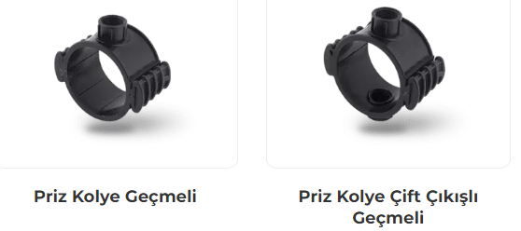

1. EXTENT

They are plastic saddles designed to be mounted on polyethylene pressure pipes used in aboveground and underground irrigation systems that carry water at temperatures not exceeding 50 °C.

2.IMPLEMENTATION

- Agricultural Irrigation
- Greenhouses

1

3. MATERIAL PROPERTIES

- Guaranteed Pressure Value;
Ø 25 mm – Ø 110 mm : PN 6 / 20 0C
- It has been produced from high quality polypropylene raw material and it has resistance to impact.
- It is designed to prevent leakage caused by the size differences of the pipes.
- O-rings are made of rubber and provide leak proofness under high pressure.
- It does not contain any harmful compounds which can change the taste or the smell of the water.
- It is compatible with ISO 13460-1 Standard.

4. APPEARANCE
There will be no burrs or other defectives on the saddles that may cause damage to the pipe or pose a safety hazard during assembly. There will be no roughness in the mouth hole of the clamps that will prevent or shorten the water flow.

5. PACKAGING
Clamp Saddles with Slide products are supplied to the market in packages in the amount specified in the parcel / bag, in a way that they will not be damaged during transportation.

6. MARKING

The following information shall be marked on a clamp as a minimum requirement:
a) Producer’s name or brand,
b) Material from which the clamp is made,
c) The nominal size of the clamp,
d) Threaded branch outlet’s threaded size
e) Nominal pressure (can be marked on the packaging or on a label).

2
7. INSPECTION AND EXPERIMENTS

Name of The Test | STANDARD | METHOD | TEMPERATURE | PN | TEST  DURATION (h) | TEST PRESSURE (bar)
Resistance to short-term hydrostatic pressure | ISO 13460-1 | item - 8.2 | 20°C | 16 | 1 | PNx1,5
 |  |  |  | 10 | 1 | PNx1,5
 |  |  |  | 6 | 1 | PNx1,5
Resistance to prolonged hydrostatic pressure | ISO 1167-1 | item - 7.3 | 20°C | 16 | 1
Resistance to prolonged hydrostatic pressure | ISO 1167-1 | item - 7.3 | 95°C | 16 | 1000
Resistance to prolonged hydrostatic pressure | ISO 1167-1 | item - 7.3 | 20°C | 10 | 1 | 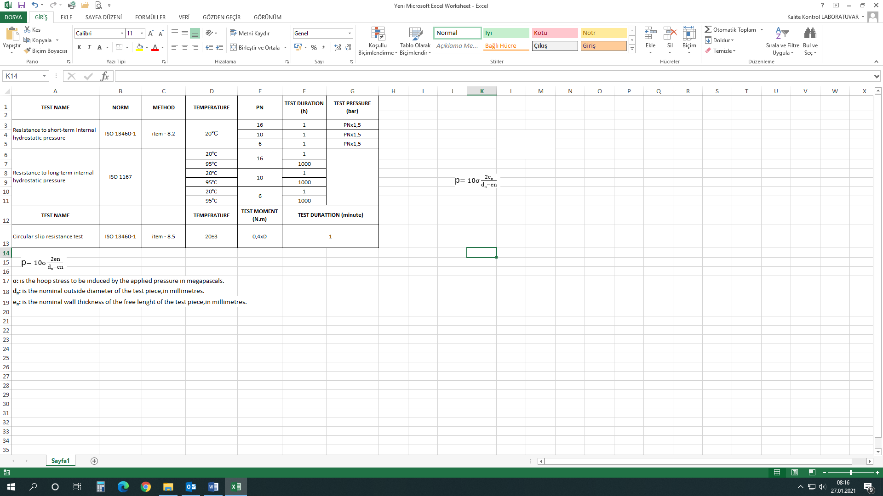
Resistance to prolonged hydrostatic pressure | ISO 1167-1 | item - 7.3 | 95°C | 10 | 1000
Resistance to prolonged hydrostatic pressure | ISO 1167-1 | item - 7.3 | 20°C | 6 | 1
Resistance to prolonged hydrostatic pressure | ISO 1167-1 | item - 7.3 | 95°C | 6 | 1000
Name of The Test | STANDARD | METHOD | TEMPERATURE | TEST FORCE (N.m) | TEST  DURATION (MIN.)
Circular slide resistance | ISO 13460-1 | article - 8.5 | 20±3 | 0,4xD | 1

3

9. USAGE INFORMATION

- Clamp saddles should be kept away from hard and sharp objects during the storage and installation. If the installation is laid under the ground, it should be covered with sand to protect it from hard and sharp objects. Any damaged adaptor should not be used absolutely.

- The O-ring should be placed in its socket properly in order not to be unsettled during the installation.

- Male adaptors which are going to be used with clamp saddles should be wrapped tight enough to prevent leakage towards fastening direction with a Teflon band.

- Drilling the pipe after the installation of Clamp Saddles can cause the damage of the threads. Thus, drilling must be carried out in a way that it does not touch the threads with a suitable drill bit.

- If there is a size difference, larger than the standard dimensions (> 0.5 mm) in the pipe, upper and lower body parts will not contact each other during the clamp saddle installation. In this case, there is no need to drive in the wedges of the clamp saddle up to the end.

4

