PRODUCT TECHNICAL SPECIFICATIONS

PE100 SPIGOT FITTINGS

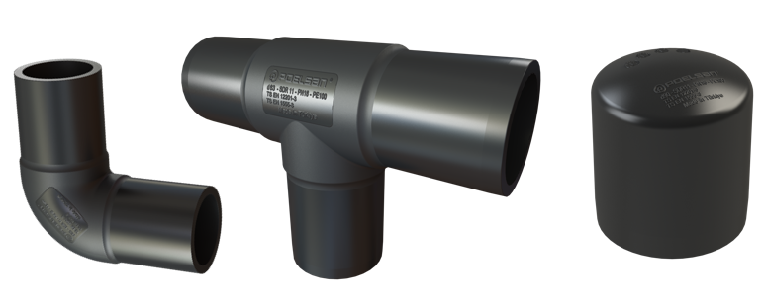

1. EXTENT

Welded fittings for polyethylene pipes

2. IMPLEMENTATION

Polyethylene Water and Natural Gas Systems

1

3. MATERIAL PROPERTIES
• Guaranteed Pressure Value;
Ø 63 mm – Ø 160 mm: 16 Bar / 20 ⁰C / Water
Ø 63 mm – Ø 160 mm: 10 Bar / 20 ⁰C / Gas
• Long-lasting use,
• Does not contain harmful compounds that can change the smell and taste of water,
• Ideal welding time, HDPE 100 certified raw material,
• Electrofusion Fittings;
- EN 12201-3
- EN 1555-3
- ISO 4427-3
- ISO 4437-3 Standards are produced.

4. APPEARANCE
When viewed without the use of a magnifying glass, the internal and external surfaces of the inserts shall be smooth and clean, free from any flaking, pitting or other surface defects that would prevent their conformity to this International Standard.

No component of the insert shall show any signs of damage, scratches, pitting, swelling, blistering or cracking that would compromise the conformity of the part to the provisions of this International Standard.

5. PACKAGING
PE fittings are placed on the market in the specified quantity in boxes/bags so that they will not be damaged during transportation.

2

6. MARKING

On the electrofusion couplings offered to the market;
• Brand information (POELSAN),
• Design Pressure (PN),
• Nominal Diameter (mm),
• Body Material (PE100),
• Manufacturing Date
• Source barcode / source information

On the packaging;
• Name of the product, code,
• Size of the product,
• Standard number,
• Area of ​​use,
• Quantity of the product,
• Company name, address and other information (brand etc.),

7. USAGE INFORMATION

• The temperature of the environment where butt welding is performed should be above +5°C. In rainy and cold weather, a covered area should be selected.

• Pipe ends should be closed to prevent rapid cooling due to air circulation during butt welding.

• Before butt welding in coiled pipes, the ovality formed during production should be removed.

• The butt welding area should be clean and undamaged.

• In order to obtain a quality butt weld, butt welding pressure, temperature and time parameters should be adjusted well.

• PE Pipe ends should be cut smoothly (at a right angle to the pipe axis).

• PE Pipe surfaces should be clean, (should be shaved with a rasp etc.)
• PE Pipe and Fittings should be cleaned with industrial cleaning wipes before welding.

• Ovality in pipes should not exceed 1.5% of their outer diameter. Otherwise, pipe clamps should be used. Pipe axis misalignments should be checked. Care must be taken to reset.

• In butt welding applications, Welding data (pressure-Force) should be in accordance with the machine instructions.

3

8. INSPECTION AND EXPERIMENTS

TEST DEFINITION | TEST CONDITIONS | METHOD | ACCEPTING CRITERIA | RAW MATERIAL TYPE | TEST DURATION
Hydrostatic strength at 20°C | 20°C / 10 Mpa | TS EN ISO 1167-1  TS EN ISO 1167-4 | There should be no leakage, cracking, etc. | PE80 | 100
Hydrostatic strength at 20°C | 20°C / 12 Mpa | TS EN ISO 1167-1  TS EN ISO 1167-4 | There should be no leakage, cracking, etc. | PE100 | 100
Hydrostatic strength at 80°C | 80°C / 4,5 Mpa | TS EN ISO 1167-1  TS EN ISO 1167-4 | There should be no leakage, cracking, etc. | PE80 | 165
Hydrostatic strength at 80°C | 80°C / 5,4 Mpa | TS EN ISO 1167-1  TS EN ISO 1167-4 | There should be no leakage, cracking, etc. | PE100 | 165
Hydrostatic strength at 80°C | 80°C / 4,0 Mpa | TS EN ISO 1167-1  TS EN ISO 1167-4 | There should be no leakage, cracking, etc. | PE80 | 1000
Hydrostatic strength at 80°C | 80°C / 5,0 Mpa | TS EN ISO 1167-1  TS EN ISO 1167-4 | There should be no leakage, cracking, etc. | PE100 | 1000
Cleavage strength for electric welded pipe end fittings | 23°C | ISO 13954 or  ISO 13955 | Initial break length ≤ L2/3 break error | PE100
Tensile strength for butt weld fittings - spigot end fitting | 23°C | ISO 13953 | Fracture test:  -ductile: pass  -brittle: do not pass | PE100
In case of error at 80°C, repeating test | 80°C / 4,5 Mpa | EN ISO 12201-3 | There should be no leakage, cracking, etc. | PE80 | 165
In case of error at 80°C, repeating test | 80°C / 5,4 Mpa | EN ISO 12201-3 | There should be no leakage, cracking, etc. | PE100 | 165
Pressure drop | Max. Diameter up to 63 | ISO 4059:1978 | Pressure drop declaration | PE100
RAW MATERIAL TESTS
Melt mass flow rate (MFR) for PE 80 and PE 100 | 5 kg / 190°C / 10 min. | TS EN ISO 1133-1 | (+) Change in MFR with 20% processing  0.20 ≤ MFR ≤ 1.40 | PE100 | 10 min.
Raw Material Density | 0,95- 0,96 gr./cm³ | ISO 1872-2  ISO 1183 |  | PE100
Thermal Stability  (Oxidation induction time) | Oxygen at 210°C (15 ±2) mg | ISO 11357-6 | ≥20 min. | PE100

4

9. PRODUCT DIMENSIONS
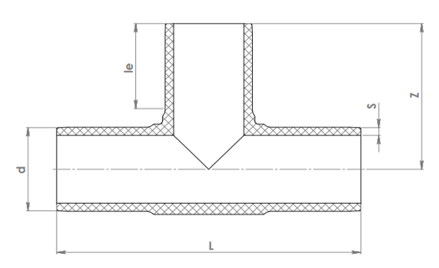

SPIGOT ELBOW DIMENSIONS
CODE | EXPLANATION | d | S | le | L | Z
SP16020606 | 63 SPIGOT EQUAL TEE | 63 | 5,8 | 64 | 221 | 111
SP16020707 | 75 SPIGOT EQUAL TEE | 75 | 6,8 | 71 | 270 | 134
SP16020808 | 90 SPIGOT EQUAL TEE | 90 | 8,2 | 80 | 300 | 150
SP16020909 | 110 SPIGOT EQUAL TEE | 110 | 10 | 83 | 332 | 168
SP16021010 | 125 SPIGOT EQUAL TEE | 125 | 11,4 | 88 | 364 | 182
SP16021111 | 140 SPIGOT EQUAL TEE | 140 | 12,7 | 93 | 380 | 190
SP16021212 | 160 SPIGOT EQUAL TEE | 160 | 14,6 | 99 | 430 | 215

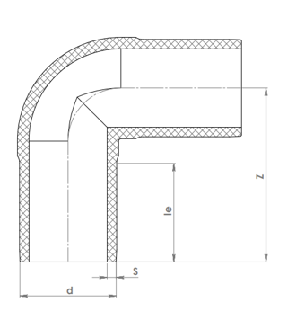
5

SPIGOT ELBOW DIMENSIONS
CODE | EXPLANATION | d | S | le | Z
SP16040606 | 63 90° ELBOW | 63 | 5,8 | 64 | 113
SP16040707 | 75 90° ELBOW | 75 | 6,8 | 71 | 120
SP16040808 | 90 90° ELBOW | 90 | 8,2 | 80 | 142
SP16040909 | 110 90° ELBOW | 110 | 10 | 83 | 164
SP16041010 | 125 90° ELBOW | 125 | 11,4 | 88 | 166
SP16041111 | 140 90° ELBOW | 140 | 12,7 | 94 | 178
SP16041212 | 160 90° ELBOW | 160 | 14,6 | 99 | 211

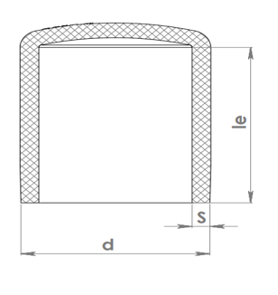

SPIGOT END CAP DIMENSIONS
CODE | EXPLANATION | d | S | le
SP16070606 | 63 SPIGOT END CAP | 63 | 5,8 | 64
SP16070707 | 75 SPIGOT END CAP | 75 | 6,8 | 73
SP16070808 | 90 SPIGOT END CAP | 90 | 8,2 | 87
SP16070909 | 110 SPIGOT END CAP | 110 | 10 | 87
SP16071010 | 125 SPIGOT END CAP | 125 | 11,4 | 91
SP16071111 | 140 SPIGOT END CAP | 140 | 12,7 | 95
SP16071212 | 160 SPIGOT END CAP | 160 | 14,6 | 107

6

