

# EXTENT

PRODUCT TECHNICAL SPECIFICATIONS

**VALVE BOXES with VALVE**

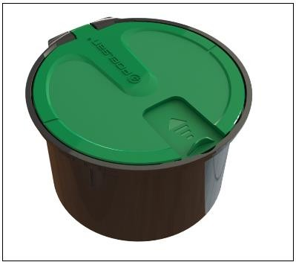 **(Metal Valve)**

Plastic valve box with a metal valve inside, used for manual irrigation in the landscape industry.

# IMPLEMENTATION

* + Landscape Industry



# MATERIAL PROPERTIES

* + It has been produced from high quality **polypropylene**.
  + Provides easy access to the metal valve connected to the underground system.
  + The hose outlet provides complete closure with a special sliding cover.
  + There are water drainage holes inside the box to prevent water accumulation.

# 3/4" BSP/Male Connection output.

* + Max. Working pressure is 16 Bar.
  + Rust-resistant metal valve.
  + Elbow – Valve connection design with increased strength.

# APPEARANCE

When plastic valve boxes are examined with the naked eye, they should have a homogeneous structure, should not contain foreign matter, and surface defects such as bubbles, cracks, deformities, and regional color differences should not be visible on the box.

# PACKAGING

Plastic valve boxes are supplied to the market in boxes that will not be damaged during transportation..

# MARKING

Valve boxes and packaging with valves put on the market;

* + Name of the product,
  + Quantity of the product,
  + Company name, address and other information (brand, etc.),
  + Manufacturing date,
  + At least one of the batch, serial or code numbers,



# INSPECTION AND TESTS

|  |  |  |  |
| --- | --- | --- | --- |
| **TEST NAME** | **UNIT** | **TEST METHOD** | **VALUE** |
| Stiffness | Shore D | TS ISO 48 | 80±5 |
| Intensity | gr/cm3 | EN ISO 1183 | 0,950±0,02 |
| Tensile Strength | MPA | ISO 527-2 | min.20 |
| Elongation | % | ISO 527-2 | min.5 |
| Masses of valve boxes | % | TS 13716 | %10 tolerance |
| Cover Load Test | N | Special Test | 1 Hour / 1500 N |
| Metal Valve Pressure Test | Bar | Special Test | 1 Hour / 24 Bar |

1. **USAGE INFORMATION**
   * Protect against sharp-edged impacts.

•

# DIMENSIONS

* + Valve Box with ¾” Valve (H x W1 x W2): 127x212x183 mm

# 3



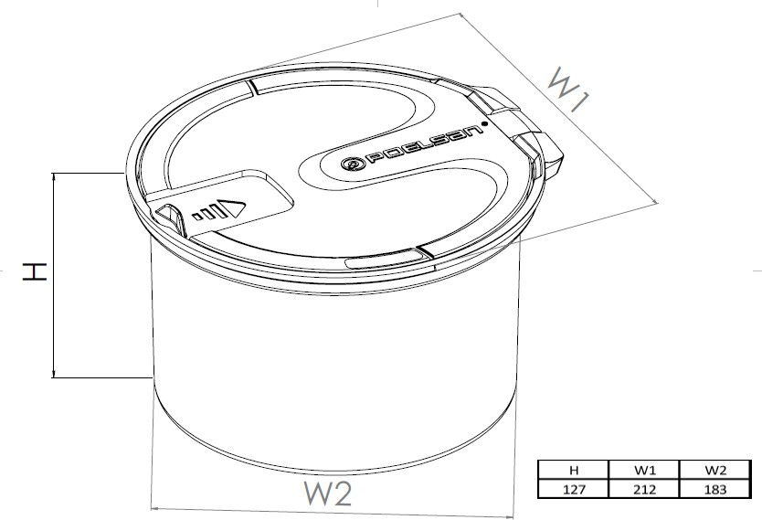

**4**