PRODUCT TECHNICAL SPECIFICATIONS

AUTOMATIC LINE FLUSH VALVE

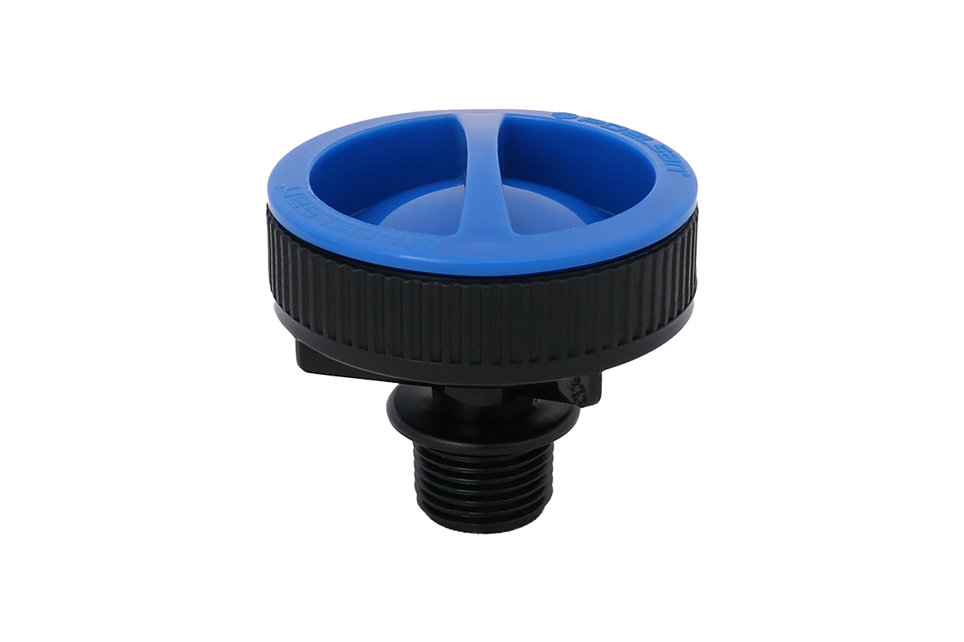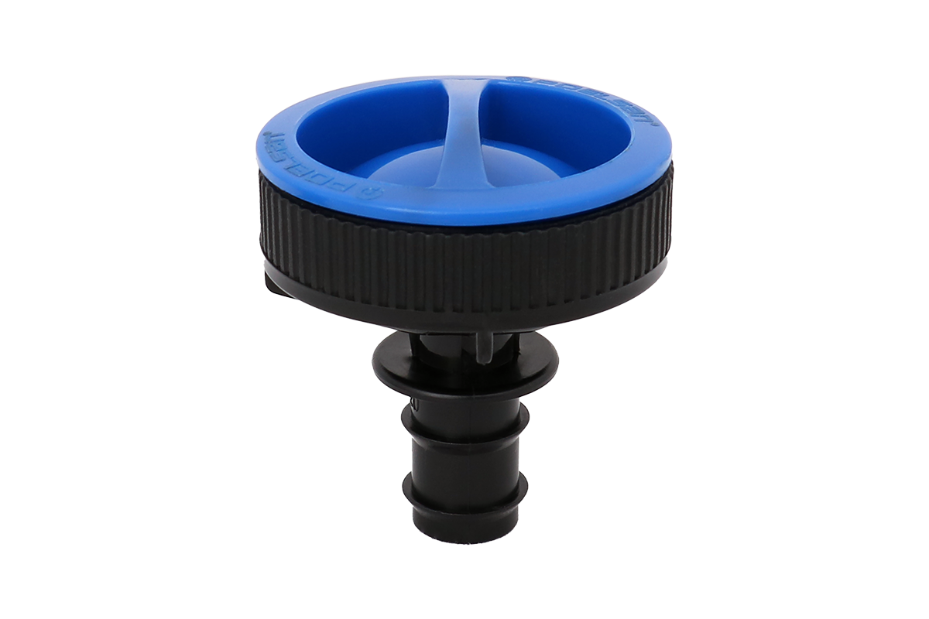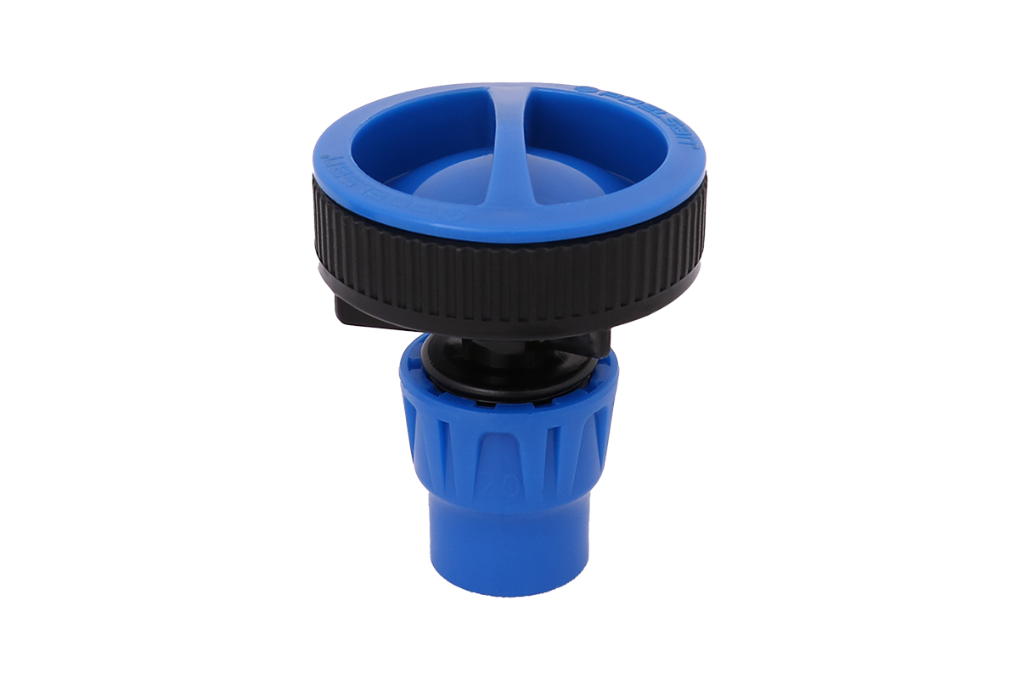

1.EXTENT

These are parts that are mechanically added to the outlet point of drip irrigation pipes and used to clean the accumulated dirt, particles, air, etc. in the system.

2.IMPLEMENTATION

• Agricultural Irrigation
• Greenhouses

1

3. MATERIAL PROPERTIES
• Guaranteed Pressure Value;
Minimum: 1.0 Bar
Maximum:4.0 Bar
Min Flow: 4,6 m³/minute

Average closing time 10-20 seconds
The average amount of water released during washing is 1-2 liters.

• Easy and practical assembly and disassembly under field conditions,

• Long-lasting diaphragm design,

• Automatic in-line cleaning and easy maintenance,

• Safe use against changing flow conditions,

• Use of materials that prioritize environmental sensitivity and impact resistance.

• Thread dimensions comply with ISO 7-1 Standard.

4.APPEARANCE
When viewed without the use of a magnifying glass, the interior and exterior surfaces of the inserts should be smooth and clean, free of any flaking, pitting or other surface defects that would prevent their compliance with this International Standard.

No component of the fitting shall show any signs of damage, scratches, pitting, blistering, blisters or cracks that would compromise the compliance of the part with the provisions of this International Standard.

5.PACKAGING
PE fittings are supplied to the market in the specified quantity in boxes/bags, in a way that they will not be damaged during transportation.

2

6.ISPECTION AND TESTS

APPLIED TEST |  | STANDARD | TEST VALUE
1 | ON-OFF CONTROL | SPECIAL TEST | ON-OFF WILL BE MADE 500 TIMES FOR 5 MINUTES EVERY 20 MINUTES
2 | RESISTANCE TO HYDRAULIC PRESSURE | ISO 9261 | 23 ^{O}C - 1 Hour - PN 3 x1,8 bar
2 | RESISTANCE TO HYDRAULIC PRESSURE | ISO 9261 | 40 ^{O}C - 6 Hour - PN 3 bar
3 | CLOSING MECHANISM CONTROL | SPECIAL TEST | Discharge Value, Closing Time, closing pressure determination
4 | TESTING AREA | SPECIAL TEST | The discharge valve will remain in the container for 1 month.
5 | TESTING AREA | SPECIAL TEST | It will be turned on and off for 1 minute and 5,000 times every 5 minutes.
6 | Outer Environment | SPECIAL TEST | Min 10 Mt Drip pipe, flat ground, 0-2 Bar
7 | Outer Environment | SPECIAL TEST | Average 10 Mt Drip pipe, 30% inclined pipe, 0-2 Bar

7.USAGE INFORMATION

• Since the number of valves to be used in the drip system affects the water capacity, attention should be paid to pump selection in the project.

• In systems where Poelsan automatıc line flush valve is used, a disc or screen filter must be used in the system.
• Poelsan automatıc line flush valve should be kept away from hard and sharp objects during storage and installation. Damaged valves should never be used.
• Teflon tape should be used in threaded connections. Teflon tape should be wrapped in the tightening direction to prevent water leakage on the automatıc line flush valve threaded parts.

• Automatıc line flush valves should be maintained periodically. During maintenance, attention should be paid to the direction of the diaphragm seal.

3

