PRODUCT TECHNICAL SPECIFICATIONS

PLASTIC FILTERS
(Sifter-Disc)

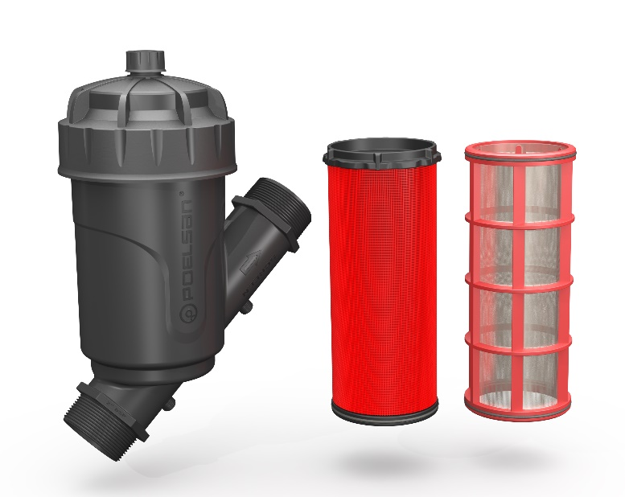

1. EXTENT

It eliminates the clogging problem by keeping dirt and particles into the line in Agricultural and Landscape Irrigation systems.

2.IMPLEMENTATION

• Agricultural watering
• Landscaping industry

1

3. MATERIAL PROPERTIES

• Guaranteed Pressure Value: PN10 / 60 ºC

• Made of high-quality polypropylene material.

• It has minimum pressure loss.

• It has the ability to operate in a wide flow range.

• It has a product design focused on easy cleanability and flexible maintenance.

• It has sensitive particle retention feature.

• It has 120 Mesh (130 Micron) Sieve and Disc Cartridge Option.

Sieve: Stainless Steel, Disc: Consists of Polypropylene (PP) raw material.

• High sensitivity to corrosion and chemicals

• Filter Manometer Output Measurement; ¼”, Flush Valve Outlet Dimension ¾”

Technical Criterion | Unit | Necessity
Connection Standard (Male Thread) |  | BSP & NPT
Connection Dimensions | inch | 3/4" | 1" | 1 1/4" | 1 ½" | 2"
Flow Range | m³/h | 5 | 6 | 10 | 14 | 25
Filter Surface Area (Sieve / Disc) | cm² | 165 / 180 | 165 / 180 | 265 / 280 | 265 / 280 | 485 / 500
Max. Operating pressure | Bar | 10
Max. Operating temperature | ºC | 60
Filter Type |  | Sieve / Disc
Number of Sieve Mesh |  | 120
Permissible Particle Size | Micron | 130
Manometer Outlet |  | ¼ " (2 Pieces)
Flush Valve Outlet |  | ¾"

4. APPEARANCE
When examined with the naked eye, Plastic Filters should have a homogeneous structure, should not contain foreign matter, and should not have surface defects such as bubbles, cracks, deformities, or regional color differences on the box.

2

5. PACKAGING
Plastic Filters are supplied to the market in bags and boxes so that they will not be damaged during transportation.

6. MARKING

On the Plastic Filters put on the market and on their packaging;

• Name of the product,
• Quantity of the product,
• Company name, address, and other information (brand, etc.),
• Connection Size (3/4”-BSP)
• Filter Direction signs
• Manufacturing date,
• At least one of the batch, serial or code numbers,

7. INSPECTION AND EXPERIMENTS

TEST DESCRIPTION | TEST METHOD | TEST CRITERIA
 |  | TEMPERATURE | PRESSURE | DURATION
Body Sealing Test | ISO 9912 | 23 °C ± 3 °C | PN x 1,5 | 5 min.
 |  | 23 °C ± 3 °C | PN x 1,5 | 15 min.
Cyclic Pressure Test | ISO 9912 | 23 °C ± 3 °C | 1 Bar- 10 Bar | 20.000 cycle
 |  |  | 1 Bar- 15 Bar | 2000 cycle
Long-term Pressure Test | SPECIAL TEST | Outer Environment | 10 Bar | 30 Day
Explosion Test | SPECIAL TEST | 23 °C ± 3 °C | Min. 20 Bar | -

3
8. USAGE INFORMATION

• Attention should be paid to the connection direction of the sieve and disc filter.
• Before operating the system, it should be checked whether the filter is clean.
• The filter should be cleaned when the difference between the filter inlet and outlet pressures is more than 1 bar.
• Filters must be cleaned regularly for the health of the system.
• For the discharge valve, the blind plug on the filter cover is removed and a ¾” female valve is installed by drilling it with the help of a drill.

9. DIMENSIONS

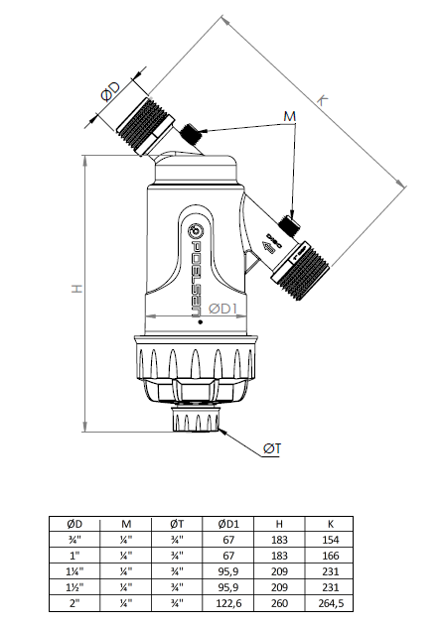

4

Plastic Filter Capacity Table

Size | Maximum flow | Filtering Surface (Disc) | Filtering Surface (Screen)
3/4" | 5 m³/h | 165 cm² | 180 cm²
1" | 6 m³/h | 165 cm² | 180 cm²
1 1/4" | 10 m³/h | 265 cm² | 280 cm²
1 1/2" | 14 m³/h | 265 cm² | 280 cm²
2" | 25 m³/h | 485 cm² | 500 cm²

Flow - Pressure Difference Graphs

