PRODUCT TECHNICAL SPECIFICATIONS

QUICK COUPLING VALVE & KEY
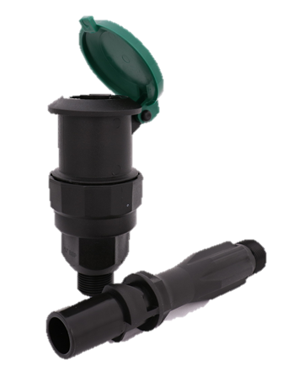

1. EXTENT

Plastic Quick Coupling Valves that provide quick access to the underground water line and manual irrigation.

2.IMPLEMENTATION

- Landscaping Systems

1

3. MATERIAL PROPERTIES
- Max. Working Pressure: PN 6 Bar
- Easy on/off with a quarter turn of the key
- Durable body that prevents foreign substances from entering inside.
- High quality durable Polypropylene raw material
- Stainless Steel spring
- Acetal Spring Inner Bushing.
- Max. Working Pressure: PN 6 Bar

4. APPEARANCE

When the Quick Coupling Valve is examined with the naked eye, it should have a homogeneous structure, should not contain foreign matter, and surface defects such as bubbles, cracks, deformities, regional color differences should not be seen on the product.

5. PACKAGING
Plastic valve boxes are supplied to the market in nylon packages in a way that they will not be damaged during transportation.

6. MARKING

On the Plastic Quick Coupling Valve and key packages released to the market;
• The name of the product,
• The quantity of the product,
• Company name, address, and other information (brand etc.),
• Production date,
• At least one of the batch, serial, or code numbers,

2

7. INSPECTION AND EXPERIMENTS

TEST DESCRIPTION | TEST METHOD | TEST CRITERIA |  |  | CONNECTION TYPE
TEST DESCRIPTION | TEST METHOD | TEMPERATURE | PRESSURE | DURATION | CONNECTION TYPE
Body Leak proofness Test | SPECIAL TEST | 20 °C ± 5 °C | 0,2 Bar | 1 Hour | KEYLESS  &  WITH KEY
Body Leak proofness Test | SPECIAL TEST | 20 °C ± 5 °C | 6 Bar | 1 Hour | KEYLESS  &  WITH KEY
Body Leak proofness Test | SPECIAL TEST | 20 °C ± 5 °C | 10 Bar | 1 Hour | KEYLESS  &  WITH KEY
Long-term Strength Test Under High Temperature Pressure | SPECIAL TEST | 40 °C ± 5 °C | 10 Bar | 240 Hours | KEYLESS  &  WITH KEY
Long-Term Leak proofness Test | SPECIAL TEST | OUTDOOR | 10 Bar | 90 Days | KEYLESS
Long-Term Leak proofness Test | SPECIAL TEST | OUTDOOR | 10 Bar | 90 Days | KEY MOUNTED
Burst Test | SPECIAL TEST | 20 °C ± 5 °C | Min.  30 Bar | - | KEYLESS  &  WITH KEY

3

8.SIZES

- Key size : 185 mm
- Valve body size : 135 mm
- Assembled product size : 260 mm

9. USAGE INFORMATION

- Teflon, etc. sealing element should be used for sealing the thread parts of the product.
- The product should not be over-strained after the end of the thread.

4

