PRODUCT TECHNICAL SPECIFICATIONS

MINISPRINKLERS & ON- LINE DRIPPERS

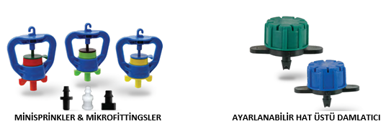

1. EXTENT

They are equipment used as micro sprinkler and adjustable on-line dripper in irrigation systems.

2.IMPLEMENTATION

- Agricultural Irrigation Systems
- Landscaping Systems
- Plantations

1

3. MATERIAL PROPERTIES

- Guaranteed Working Pressure;
Minisprinkler working pressure : PN 2
- Mini sprinklers are used in Ø16 mm, Ø20 mm, Ø25 mm and Ø32 mm Low Density Polyethylene Pipes (LDPE) (Flat Drip Irrigation Pipe) and Ø7 mm Spagetti Tube together with Micro fittings.
- Rotors of Mini sprinklers are designed to prevent the entry of dust and insects, etc.
- It is the most ideal product to be used in irrigation and provides maximum efficiency.
- Rotating Mini sprinklers provide necessary irrigation directly to the roots of a plant.
- It provides effective protection against cold weather conditions.
• Adjustable On-Line drippers are used in Micro fittings and Ø7 mm Spaghetti pipes.
- The dripper's cover is easy to remove and install, making it easier to clean the dripper.

4. APPEARANCE
When viewed without the use of a magnifying glass, the inner and outer surfaces of the products should be smooth and clean, with no flaking, pitting or other surface defects.

5. PACKAGING
Mini sprinklers, Adjustable on-line drippers are supplied to the market in packages in the amount specified in the parcel / bag so that they will not be damaged during transportation.

6. MARKING

On the products and packages of Mini sprinklers and On-Line drippers introduced to the market;

• Discharge Value (Liters)
• Working Pressure (PN)
• Size (mm)
• POELSAN
• Raw Material Information PP/POM writes the information.

2
7. INSPECTION AND EXPERIMENTS

Mini sprinklers and On-Line Drippers are subject to function, liter and wetting diameter controls at the following pressure values.

PRODUCT GROUP | PRESSURE VALUE  (Bar) | TEST TEMPERATURE  (°C) | TEST DURATION  (Hour) | EXPLANATION
Mini sprinklers | 0,5 / 4,0 | 20 | 30 min. | Minis prink operation is checked.
Mini sprinklers | 2 | 20 | 30 min. | Wetting diameter and discharge value are checked.
Adjustable Inline Dripper | 0,5 / 3,0 | 20 | 30 min. | Discharge value is controlled by the number of clicks.

9. USAGE INFORMATION

- For the installation of the Ø7 mm barbed end to the Low-Density Polyethylene Pipe (LDPE), the pipe should be punched Ø3 mm.
- Using Rotating Mini sprinklers with the deflector on the rotor will be more efficient for young plants. Bigger plants need a wide scaled irrigation, therefore Mini sprinklers are used by fracking the deflectors on the rotor.
- On – Line Drippers are easily inserted by punching a 3 mm hole on the pipe.
- The minimum filtration capacity of the filter used in the system shall be 125 microns.

3
Minispring Mounting Type;

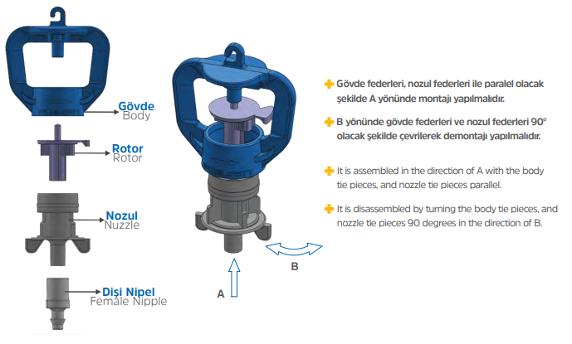

4

