PRODUCT TECHNICAL SPECIFICATIONS

THREADED FITTINGS

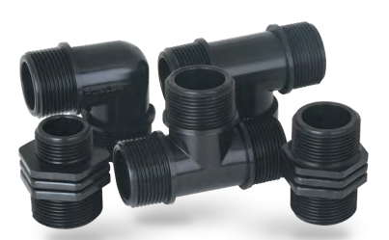

1. EXTENT

They are plastic threaded inserts used with one piece, valves, etc. products in irrigation systems.

2.IMPLEMENTATION

- Landscaping Systems
- Agricultural Irrigation

1

3. MATERIAL PROPERTIES
- Guaranteed Pressure Value;

1/2” – 4” : PN 10 / 20 0C
- It has been produced from high quality polypropylene raw material and it has resistance to impact.
- • Threaded fittings' threaded parts comply with ISO-7 norms.
- • Threaded fittings do not allow algae and bacterial growth as they do not pass ultraviolet rays (UV).
- • Inner surfaces are homogeneous and non-porous.
- • Threaded fittings; threaded parts are suitable for use with ball valves, galvanized fittings, etc.
- • Threaded connection Collector TE; It does not require an O-ring for installation, it is self-O-ring.
- • Threaded connection Collector TE; Used to install BSP female valves and valve manifold.

4. APPEARANCE
When viewed without a magnifying glass, the interior and exterior surfaces of the fittings should be smooth and clean, with no flaking, pitting or other surface defects that would prevent their conformity with this International Standard

5. PACKAGING
Threaded fittings are supplied to the market in the amount specified in the parcel / bag, in a way that they will not be damaged during transportation.

6. MARKING

On the products and packages of Threaded Connection Fittings offered to the market;
• Thread Size (inch size)
• Nominal Pressure (PN)
• POELSAN
• Raw Material Information PP writes the information.

2
7. INSPECTION AND EXPERIMENTS

Threaded Fittings are subjected to leak proofness test at the following pressure values.

SIZE | Connection Material | PRESSURE VALUE  (Bar) | TEST TEMPERATURE  (°C) | TEST DURATION  (Hour) | TEST PRESSURE  (Bar) | EXPLANATION
½” – 4” | Plastic | 10 | 20 | 1 | 10 | There will be no leakage
½” – 4” | Metal | 10 | 20 | 1 | 15 | There will be no leakage
½” – 4” | Metal | 10 | 50 | 24 | 10 | There will be no leakage

9. USAGE INFORMATION

- Sealing elements such as Teflon should be used to seal the threads of the products.
- Products should not be forced after thread end.

3

