PRODUCT TECHNICAL SPECIFICATIONS

BLUE SERIES COMPRESSION FITTINGS
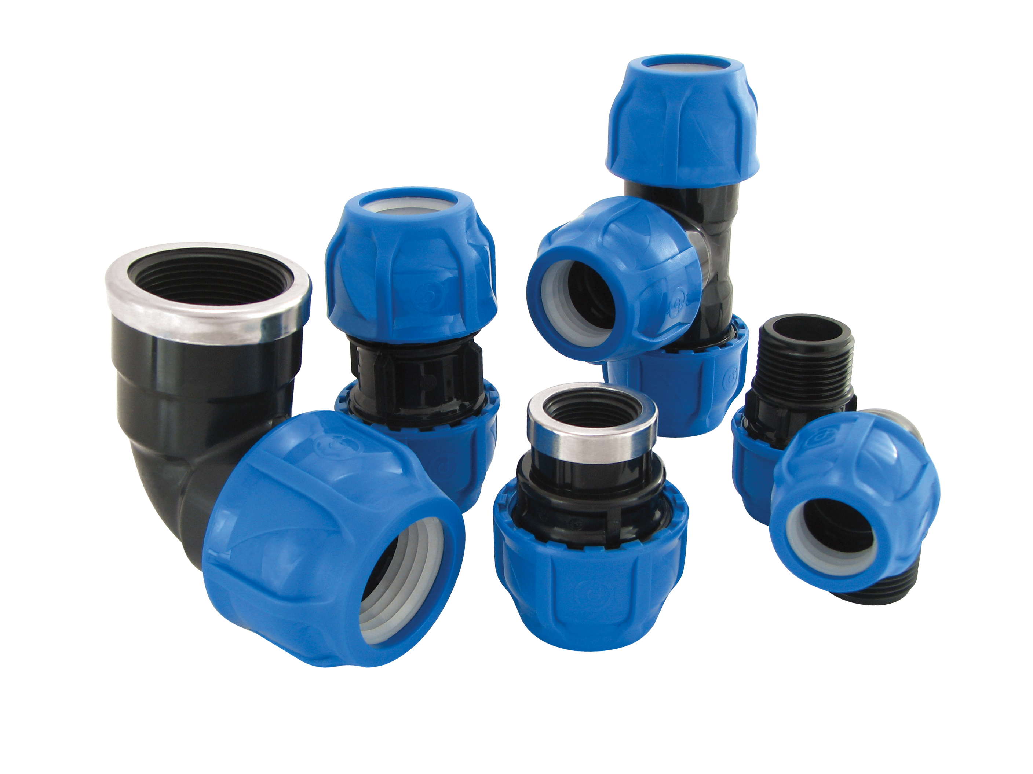

1. EXTENT

They are the parts used for mechanical joining of polyethylene pipes.

2.IMPLEMENTATION

•Drinking water
• Landscape industry
•Agricultural watering

1

3. MATERIAL PROPERTIES

• Guaranteed Pressure Value;

Ø 20 mm – Ø 110 mm : 20 ⁰C / PN 16
Ø 125 mm : 20 ⁰C / PN 10

- It has been produced from high quality polypropylene raw material and it has resistance to impact.

- Prevents problems that may consist of measurement differences or ovality in the pipes thanks to conical squeezing properties.

- They prevent alga and bacteria forming due to UV proof (ultraviolet beam) structure.

- O-rings are made of rubber and provide leak proofness under high pressure.

- It has a homogeneous and non-porous inner surface.

- It does not contain any harmful compounds which can change the taste or the smell of the water.

- Our female products provide high impermeability at variable temperatures thanks to the corrosion resistant metal ring.

- Thread size compatible with ISO 7-1 standards

- It is compatible with ISO 17885 standards.

4. APPEARANCE

When viewed without a magnifying glass, the interior and exterior surfaces of the fittings should be smooth and clean, with no flaking, pitting or other surface defects that would prevent their conformity with this International Standard. No component of the insert shall show any signs of damage, scratches, pitting, blistering, blisters, or cracks that would overshadow the compliance of the part with the provisions of this International Standard.

5. PACKAGING

PE fittings are supplied to the market in packages in the amount specified in the parcel / bag, in a way that they will not be damaged during transportation.

2
6. MARKING
Embossed on the Mechanical fittings offered to the market;
• Brand information (POELSAN),
• Design Pressure (PN),
• Nominal Diameter (mm),
• Body Material (PP),
• Production date
On the packaging;
• Product Name, code,
• Dimension of the product,
• Standard number,
• Usage area,
• The quantity of the product,
• Company name, address and other information (brand etc.),

7. INSPECTION AND EXPERIMENTS

Name of The Test | ISO | STANDARD SERIAL NUMBER | TEMPERATURE | PN | TEST  DURATION (h)
Body resistance test | ISO 1167-3 | 9.2 | 20°C | 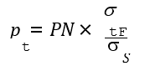 | 1
Body resistance test | ISO 1167-3 | 9.2 | 95°C |  | 1000
Impermeability under internal pressure | ISO 3458 | 9.3.3.1 | 20°C | PN X 1,5 | 1
Long-term pressure testing for impermeability under internal pressure | ISO 3458,  ISO 1167-1 | 9.3.3.2 | 20°C | PN X 1,2 | 1000
Separation resistance at a temperature of 23°C | ISO 3501 | 9.3.3.4 | 23 °C |  | 1
Impermeability under internal pressure when twisted | ISO 3503 | 9.3.3.7 | 23 °C | PN X 1,5 | 1
Impermeability under negative pressure | ISO 3459 | 9.3.3.8 | 20°C | 100+50 mbar | 1
Impermeability under negative pressure | ISO 3459 | 9.3.3.8 | 20°C | 800 ± 50 mbar | 1
3

9. USAGE INFORMATION

• Poelsan fitting for roll pipes should be kept away from hard and sharp objects during storage and assembly. If the installation is to be laid underground, it should be covered with sand in order to protect it from hard and sharp objects. Damaged adapters should never be used.

• In order to get maximum efficiency from Poelsan pipe fitting adapters, tees and elbows should be mounted to the pipe at an angle of 90° and other adapters at an angle of 180°. As the connections forming different angles will cause extension on the adapter, the life of the installation will be reduced.

• Teflon tape should be used on threaded connections. Teflon tape should be wrapped around the adapter enough to prevent water leakage and in the tightening direction.

• Over tightening of the nut during assembly causes additional extension on the adapter. The product, which has been subjected to an additional extension in this way, cannot be expected to meet the guaranteed pressure values. For this reason, it should not be forgotten that the product is plastic and should only be tightened with the force to ensure the tightness.

4

